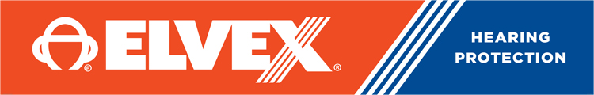

משקפי מגן עדשות כהות
DKR ELVEX SG-400- atom IN-OUT
מקט 4002133

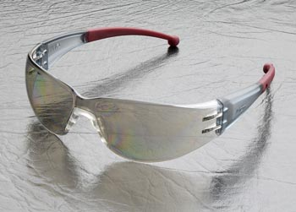

Sleek, Comfortable and Economical!
Atom stands for simplicity but this safety safety glass still offers great style and excellent fit. This stylish model is light weight and fits against the nose and ears with soft rubber pads. Cool, colored temples add flair.
- Available in the following lens versions: clear, clear anti-fog, blue, indoor/outdoor, gray and silver mirror
- Polycarbonate lenses offer great coverage and 99% UV protection
- This model provides extra space for your eye lashes
- Soft rubber nose bridge and temple tips.
- Very economical pricing!
- Complies with ANSI Z87.1-2010 (Z87+).
- Complies with CE EN-166.

מארז
