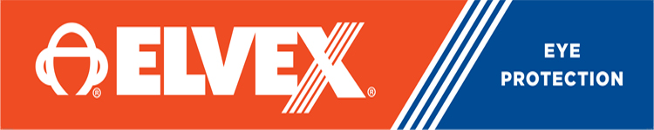

משקפי מגן ושמש עדשות מראה מוזהבות
DKR ELVEX SG-350M

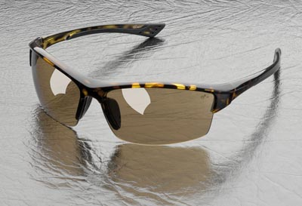

Sonoma™ safety glasses,
great style and sophisticated design!
The new Sonoma safety glass model is probably the best looking model in our product line. It seems to fit a great variety of facial configurations as well.

Sonoma, SG-350, safety glasses offer the following features:

Sophisticated design and great style!
Skin tone frame colors, including tortoise finish.
Clear, light brown, brown and gold mirror lens options, for different work environments.
The brown lens provides the same light attenuation (18-20%) as our standard NCB gray lens.
Complies with ANSI Z87.1-2010 (+)
מתאים למגוון רחב של צורות פנים.
מסגרת משקפיים בצבעי עור עם גימור צב
ANSI Z87.1-2010 (+) עומד בתקן

מארז
