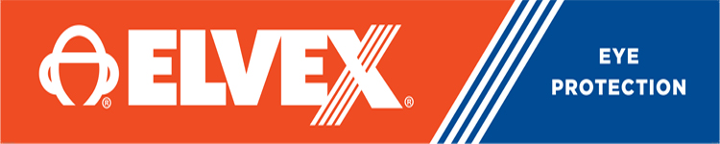

משקפי מגן עדשות בהירות מסגרת אפורה
ELVEX SG350CGRAYELVEX SG-350C
מקט 4002021

Sonoma™ Clear HC/PC Lens, Glossy Gunmetal-Grey Frame

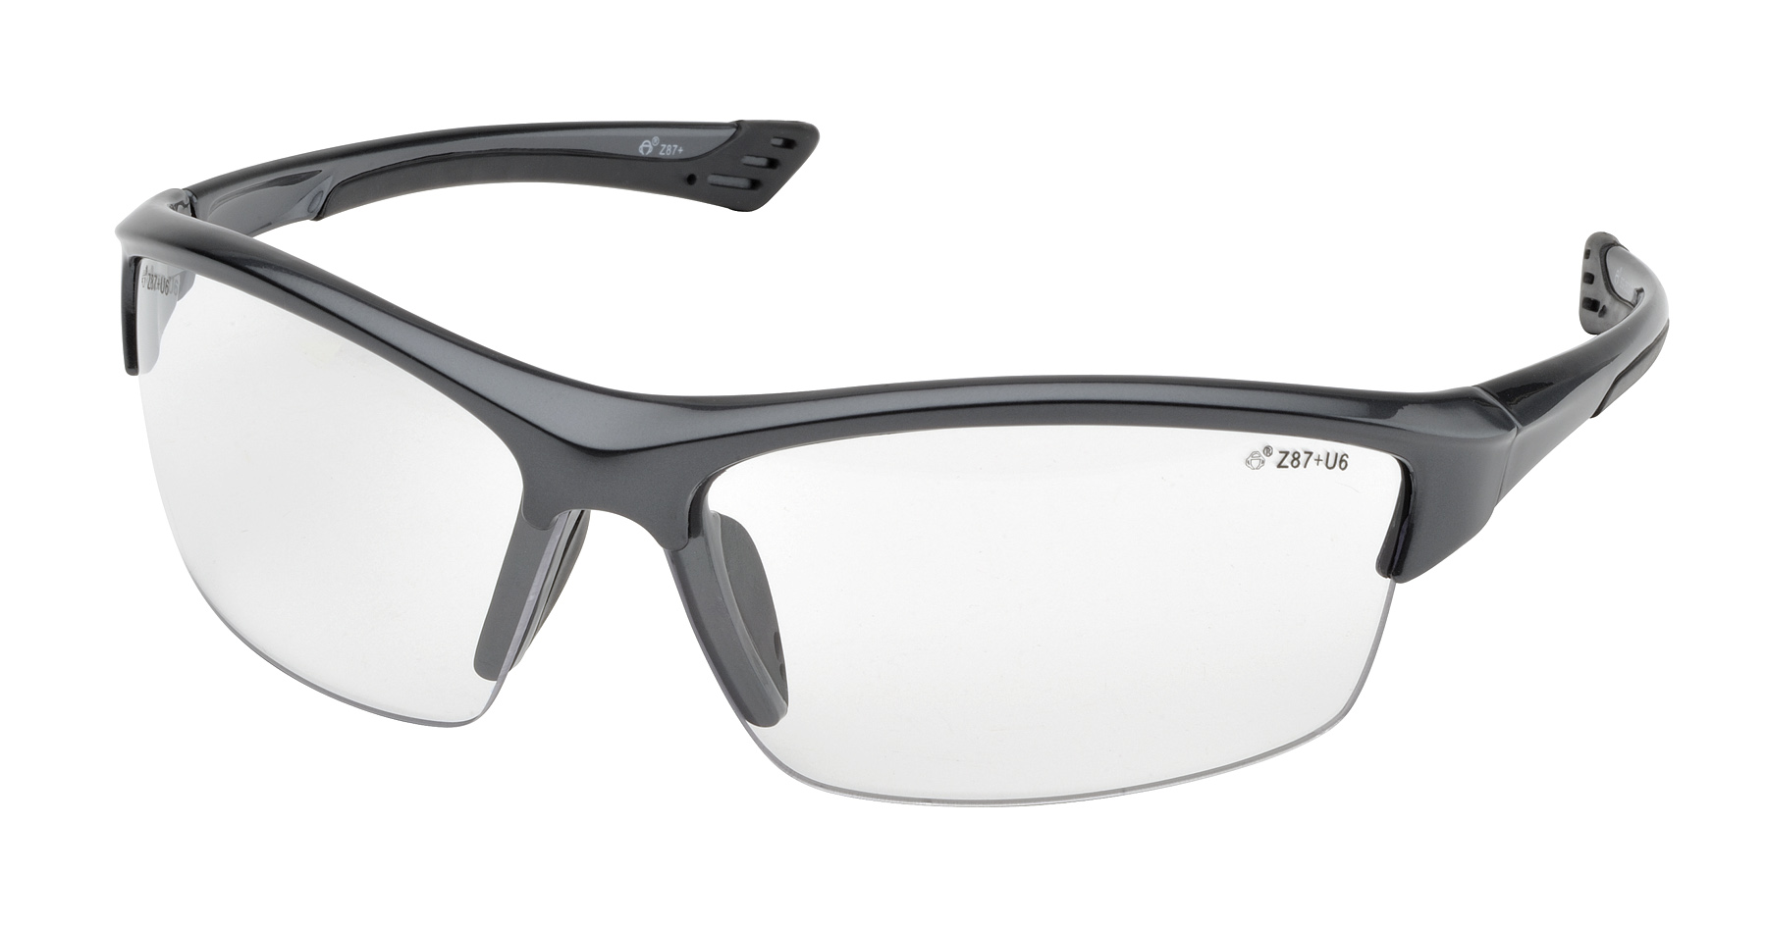

The new Sonoma safety glass model is probably the best looking model in our product line. It seems to fit a great variety of facial configurations as well.

Sonoma, SG-350, safety glasses offer the following features:

Sophisticated design and great style!
Skin tone frame colors, including tortoise finish.
Clear, light brown, brown and gold mirror lens options, for different work environments.
The brown lens provides the same light attenuation (18-20%) as our standard NCB gray lens.
Complies with ANSI Z87.1-2010 (+)

משקפים בעלות עיצוב מתוחכם המתאימות למגוון רחב של צורות פנים
ANSI Z87.1-2010 (+) עומד בתקן

