מקט 4001339

סרבל מגן 65 גר' +טייפ כחול XXL רוכסן עם כובע אטום לבן DKR30223

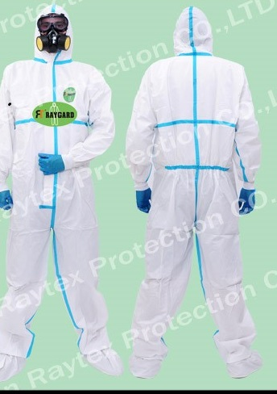

Protective coverall 30203 PLUS is designed to help protect against certain light liquid splashes(Type 6) and hazardous dusts (Type 5) and liquid chemicals (Type 4)
Microporous 60g/m² , with hood. Zip front opening covered by self adhesive flap, elastic at cuffs, ankles, hood and waist, heat sealed seams with tape.
CATIII type 4/5/6 can be certifiled EN1149-5: 2008

Material: Microporous 60g

